COMPANY ENVIRONMENTAL POLICY STATEMENT

Tuke & Bell Ltd are manufacturers and installers of sewage treatment equipment, based in an industrial area of Lichfield. Our customers include all the UK water companies and a range of private clients.

The company is aware of its responsibility to minimise the environmental impact of its products and of its activities both in the manufacturing premises and during installation on client sites. The company understands that good environment management reduces costs and can be the basis of future sales.

Tuke & Bell will:

- Comply with all relevant regulatory requirements and environmental legislation.

- Reduce the environmental impact of, and prevent pollution from, its manufacturing processes and products.

- Operate in a socially responsible and ethical manner in its dealings with customers, suppliers and any interested parties such as regulators, stake holders and the general public.

- Set objectives and targets to continually improve our environmental performance and monitor our progress through measurement, inspection, audit and review.

- Publish this policy to the general public, potential and existing clients through conventional marketing methods and on the company’s web site.

- Ensure all employees are: aware of this policy, suitably trained to meet their environmental responsibilities and involved in the achievement of our environmental objectives.

- Provide adequate resources to establish, document, implement and maintain an environment management system and continually improve its effectiveness to reduce the impact of Tuke & Bell products and activities on the environment.

The Company intends to ratify these measures by installing a management system compliant with BS EN ISO 14001.

Responsibility for establishing and implementing this policy is carried by the Group Managing Director and this responsibility is discharged by the Environment Management Team. The company is committed to providing sufficient resources to place its environmental performance on a par with best practice in the water industry.

This policy and the arrangements for its implementation are reviewed following the introduction of new products or activities, new materials and when environmental legislation relevant to the company is introduced or amended. The time between reviews will not exceed 12 months.

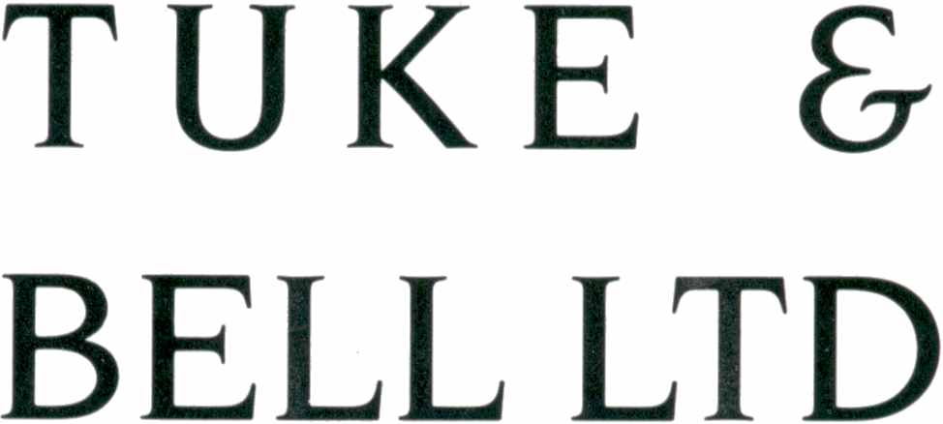


R G LEWIS
Group Managing Director

Date 15 September 2005

